**Ganpat University**

**Faculty of Engineering & Technology**

**Computer Science & Engineering**

**Practical_2**

***Name:- Dwij Vatsal Desai***

***Sem:- 3***

***Sub: - DS(Data Steucture)***

***Enrollment No.:- 23162121027***

**2.1 Calculator**

Write a program that asks the user to enter two numbers, obtains them from the user and prints their sum, product, difference, quotient and remainder.

Code:

*#include* <stdio.h>

int main(){

    int a,b,sum,product,difference,quotient,remainder;

    int choice;

    printf("Enter 2 Value:\t");

    scanf("%d %d",&a,&b);

    printf("\nChoice your preference:\n");

    printf("1) Sum\n");

    printf("2) Product\n");

    printf("3) Difference\n");

    printf("4) Quotient\n");

    printf("5) Remainder\n");

    scanf("%d",&choice);

*switch* (choice)

{

*case* 1:

            sum = a+ b;

            printf("Sum = %d",sum);

*break*;

*case* 2:

            product = a* b;

            printf("Product = %d",product);

*break*;

*case* 3:

            difference = a - b;

            printf("Difference = %d",difference);

*break*;

*case* 4:

            quotient = a / b;

            printf("Quotient = %d",quotient);

*break*;

*case* 5:

            remainder = a % b;

            printf("Remainder = %d",remainder);

*break*;

*default*:

            printf("\n\nERROR:Wrong entered number");

*break*;

    }

*return* 0;

}

Image:

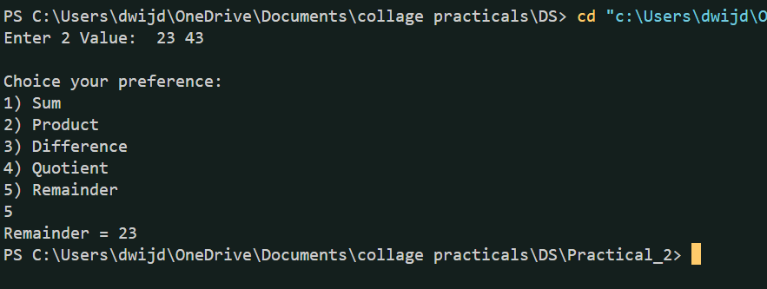

**2.2 Cost Price Problem**

Suppose, a user enters the total selling price of 15 items and the profit earned on the total. Write a program to find out the cost price of one item.

Code:

*#include* <stdio.h>

int main(){

    float Tprice,Tprofit,Tprice_item,price_item;

    printf("Enter the total price of the items: ");

    scanf("%f",&Tprice);

    printf("\nEnter the total profit earned: ");

    scanf("%f",&Tprofit);

    Tprice_item = Tprice - Tprofit;

    price_item = Tprice_item / 15;

    printf("\nThe cost price of one item is: %.2f\n", price_item);

    printf("And total price of 15 items is: %.2f",Tprice_item);

*return* 0;

}

Image:

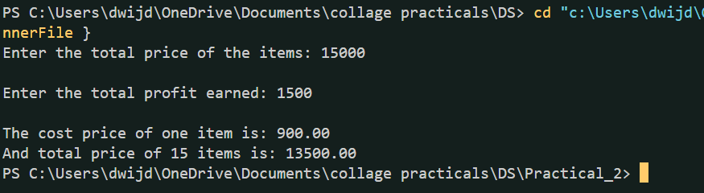

**2.3 Separating Digits in an Integer**

Write a program that inputs one five-digit number, separates the number into its individual digits and prints the digits separated from one another by three spaces each. [Hint: Use combinations of integer division and the remainder operation.] For example, if the user types in 42139, the program should print

Output: 4 2 1 3 9

Code:

*#include* <stdio.h>

int main(){

    int Digi5=0,digi[5];

    printf("Enter the five-digit number:\t");

    scanf("%d",&Digi5);

*if* (Digi5 >= 10000 && Digi5<=99999)

    {

*for* (int i = 0; i < 5; i++) {

            digi[4- i] = Digi5 % 10;

            Digi5 /= 10;

        }

        printf("Digits: ");

*for* (int i = 0; i < 5; i++) {

            printf("%d ", digi[i]);

        }

        printf("\n");

    }*else*{

        printf("\n\nERROR:Entered number is not five-digit long");

    }

*return* 0;

}

Image:

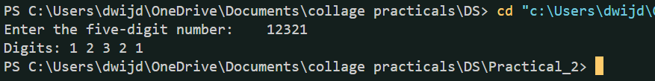

**2.4** Shapes with Asterisks Write a program that prints the following shapes with asterisks.

Code-1:

*// Q-1*

*#include* <stdio.h>

int main(){

    int hight,wight;

   printf("Enter the vlaue of Hight and Wight:- \n");

   printf("Hight:\t"); scanf("%d",&hight);

   printf("Wight:\t"); scanf("%d",&wight);

*for*(int i=0;i<hight;i++)

    {

*for* (int j = 0; j < wight; j++)

        {

*if* (i==0 || i==hight-1 || j==0 || j==(wight-1))

            {

                printf("*");

            }*else*{

                printf(" ");

            }

        }

        printf("\n");

    }

*return* 0;

}

Image:

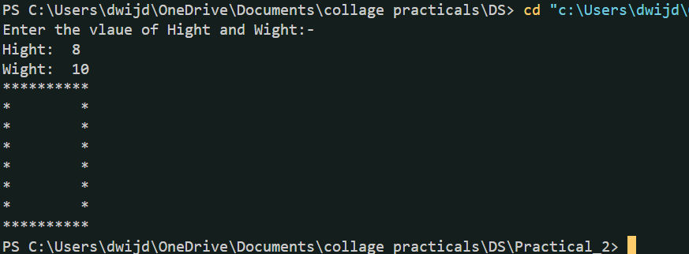

Code-2:

*//Q-2*

*#include* <stdio.h>

int main() {

    int n = 5;

*for* (int i = 0; i < 2 * n - 1; i++) {

        int spaces = n - 1 - (i < n ? i : 2 * n - 2 - i);

        int stars = 2 * (i < n ? i : 2 * n - 2 - i) + 1;

*for* (int j = 0; j < spaces; j++){

            printf(" ");

        }

*for* (int j = 0; j < stars; j++){

            printf(j == 0 || j == stars - 1 ? "*" : " ");

        }

        printf("\n");

    }

*return* 0;

}

Image:

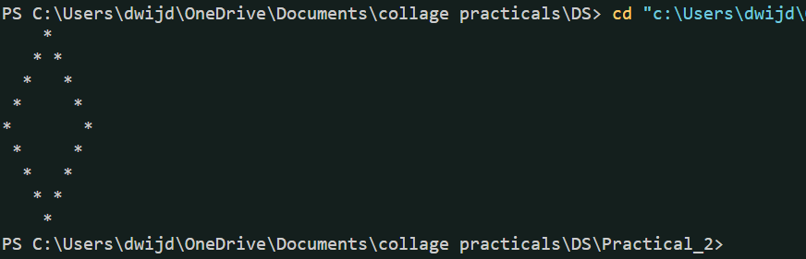

Code-3:

*//Q-3*

*#include* <stdio.h>

int main(){

    int size=0;

    printf("Enter the size of stucher:- ");

    scanf("%d",&size);

*for* (int i = 0; i < size; i++)

    {

*for* (int j = 1; j < i; j++)

        {

            printf("*");

        }

        printf("\n");

    }

*return* 0;

}

Image:

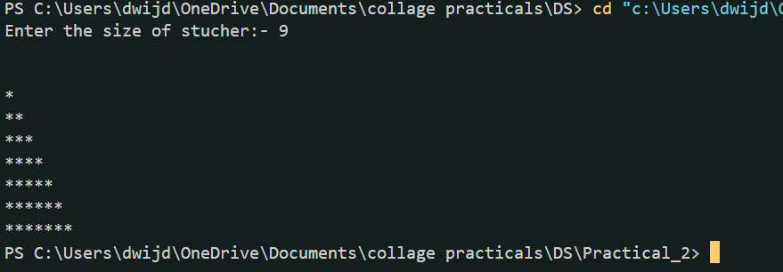

**2.5** Diameter, Circumference and Area of a Circle Write a program

that reads in the radius of a circle and prints the circle’s

diameter, circumference and area. Use the constant value

3.14159 for π.

Code:

*//Q-3*

*#include* <stdio.h>

int main(){

    float radius,diameter,circumference,area,pi=3.14159;

    printf("Enter the value of Radius: ");

    scanf("%f",&radius);

    diameter = radius* radius;

    circumference = 2* radius* pi;

    area = pi* radius* radius;

    printf("\nOutput:-\n");

    printf("Diameter: %.4f\n",diameter);

    printf("Circumference: %.4f\n",circumference);

    printf("Area: %.4f\n",area);

*return* 0;

}

Image:

